***A Story of Me***

*Introduction*

*Hi everybody,*

*I am Nurgul and I live in Germany. I wrote this book when I was stuck at home at the times of Coronavirus. I always imagined of the life I want to have and always thought what would happen if I was a fictional character. So, one day I decided to write a book in which the main character is me, but in a really different way. Everything she has is not real, even her appearance. In the first part of the book this girl or more accurately Jess goes to a boarding school. The reason is she is being bullied and hates her school. I got this idea because I was being bullied too. When I was 10, I was using a school bus. And there was a really strange boy in there. I was new to the school and I didn’t know anybody, but bye chance I became close friends with that boy’s sister. She was kind of different, but otherwise she was a really good friend or at least I thought so at that time. One day we had an argument and she said we could NOT be friends anymore. At first, I asked her to forgive me, but when she didn’t, I said to her that I didn’t want to be friends with her either. I assured myself that I didn’t care about her friendship, but I knew that I did care about its deep down. Anyway, after some time, I made lots of friends and forgot about my doubts. And I didn’t think it was a big deal because she was a year smaller than me. However, after a week or more had passed I understood that I was wrong. She started coming really hard on me. But, don’t get me wrong she didn’t bully me, her brother did. One day he said really hurtful things and I couldn’t take it anymore. So, I told my parents about it and they talked to school management about it. That boy got detention and that was all. For some time, he left me alone, but not for too long. He continued again and again. One day I told my teacher about it. She was called Miss Mercy. Although she was not my mentor, she was the only teacher I could talk as my equal without getting involved in any formal stuff. Don’t get me wrong my mentor teacher Miss Naila was really kind too, but Miss Mercy was different from her. She let me stay at class and study when everybody was outside (I hated going outside). I could use her electronic board find some information. I mean maybe she would do that to every student, but I kind of felt a bond with her. Anyway, when I told her about the bully, she recognized him because she had taught my REALLY GOOD FRIEND, Sona and my bully, Hamid was Sona’s brother. I don’t know what happened later, but Hamid got kicked out of the bus. Later I ended the war with Sona peacefully, but the truth is I don’t know how peaceful it is as she got kicked out of the bus just like her brother. In the following chapters of the story Jess fights a bully… In the second part of the book she finds out she had a cousin, but because of the family matters no one told her about it. As time flies, Jess meets her hidden family member and they unite again. Then she gets kidnapped…*

*I mean I did tell you that I took some parts from my life, but only bullying scene. I am just a normal girl with no adventure in my life. As I said before that is the reason why this book is too unreal. What I mean is it’s impossible to have such a cool life.*

*Part 1*

***Boarding School***

***Chapter one***

*Hey everyone! Welcome to my* ***fictional*** *life. As I say* fictional*, not* ***real****. I am even going to change my name. I like to imagine, but first you should know some facts about real me:*

***My true name:*** *Lily Brown*

***My true age:*** *11 (will be twelve on 21st of November)*

*So now you know three important real facts about me, it’s time you learn who I am in this cool and interesting fantasy world.*

***My fictional name:*** *Jessica Brown*

***My fictional school:*** *Auradon*

 ***My fictional age:*** *12*

**Chapter two**

*So, one day when I was sitting on my bed listening to my favorite songs my parents called me downstairs and said “We want to send you to a boarding school. Do you want to go?” And I was like, “Yeah, of course I do”. New school means new experience. And also, a fresh page which is just what I need. The reason is in my school I was being bullied. I was trying to persuade my parents to send me to another school for a month and it WORKED!!! Anyway, my boarding school was really expensive, and my mom went to that school too when she was my age.*

***P.S: Auradon Prep is just a super expensive boarding school.***

*So then on the 31st of October my parents took me to the boarding school.*

***P.S: The school starts on 1st of September.***

**Chapter three**

*Now that I have arrived at the school, I need to make some friends, because I don’t want to hang around the school alone. Just as I was thinking I bumped to someone, the perfect way to meet. I looked up to see the shyest girl I had ever seen in my life. She had curly, light brown hair and beautiful brown eyes.*

**Unknown girl:** Oh, I am really sorry! Now your dress is ruined with coffee stains.

**Me:** No problem, I was going to change anyway, I hate this dress!

***P.S: Actually, I really DO hate this dress. My mom made me wear it and I was looking for an excuse to change (I have recently bought a new dress which was really fashion forward unlike the one I was wearing right now.)***

**Me:** By the way I am Jessica Brown or shortly Jess. Nice to meet you!

**Unknown girl:** I am Belladonna Roberts or shortly Belle. Nice to meet you to! Can we be best friends? I am really shy in introducing myself and I am sure that if we don’t be friends I will hang around alone for the whole school year!

**Me:** Sure, no problem. By the way, your dress is totally amazing!

**Belle:** Really? I bought it recently! I am so lucky to be friends with you! You are the best looking girl I have seen since coming here!

**Me:** Yeah, of course I am. Anyway for how long did you study in here?

**Belle:** Not that long, but one and a half year.

**Me:** Okay, that’s long enough. So, tell me who is the most popular girl in our year?

**Belle:** Its Blair Willows. Her father is really rich and is friends with principal.

**Me:** She is just famous because of her father is rich, well not any more. My father is millionaire and my family is close friends with the principal’s family. Principals like people who donate money to their schools. My father decided to donate 10,000$ to school.

**Belle:** Well seems like someone will be going down. Oh, there she is. All the new girls are supposed to introduce themselves to her. So she can see if they are good enough to be in her GANG.

**Me:** I will NOT introduce myself to her. I know that I am not good enough I a-

**Belle:** Of course you ARE!

**Me:** I was going to tell I am PERFECT, but thanks for trying to support me anyway.

*So there stood the most arrogant looking girl I have ever seen. She was looking towards me expectantly, but I pretend not to see her. Even though I was having a friendly conversation with Belle, I knew that I had declared a war with Blair Willows.*

**Chapter four**

*So today is the 1st day of school and as there is no uniform I chose my best dress, took my schoolbag and headed for breakfast. There I met Belle. We ate while gossiping about school staff members. Just as we were finishing our meal our dear frenemy approached.*

**B. Willows:** Hey there! You must be the new girl. I am Blair, Blair Willows. You don’t have to seat with losers, you can sit with us!

**Me:** Oh, you mean that Belle is a loser?!

**B. W:** Aha!

**Me:** Hmm…

**Belle:** Look, you don’t have to be friends with me if you don’t want to. It’s OK…

*I wasn’t really going to say yes to B.W’s offer anyway, but as I saw sadness flowing through Belle’s eyes I knew that she was a real friend and she would never leave when I most needed her.*

***Me:*** The only real loser in here is YOU, Willows. Now get away from my BEST FRIEND before you get seriously injured, not physically mentally*.*

*As I saw Belle’s eyes filing with joy I assured myself that I have done the right thing.*

**B.W:** You will regret this choice little one or should I say loser’s little friend.

**Me:** Firstly, I am Jessica Brown. Secondly, I know you expect me to insult you, but I won’t instead I will just say something to your “friends” or would servants be a more accurate term?! Anyway girls I know that you already became her “faithful minions”, but still I want you to know that she is using you just like all the bullies I have ever met… Now bye everybody I have got a lesson to go.

*In the corridor*

**Belle:** You were amazing out there! Thanks for standing up for me!

**Me:** Thanks, that means a lot coming from you. Anyway which lesson do we have?

**Belle:** We have… Oh goodness, hurry you wouldn’t want to be late for miss T’s lesson on the first day of school!

**Me:** Miss who?!

*In the class*

**Miss T:** Hello everybody. Lots of you already know me, but for those who are new I am miss T…

**Me:** Hey miss Taylor!

**Miss T:** Oh hey Jessica I didn’t know you would be taking my classes this year.

*15 minutes later*

**Belle:** Do you by ANY CHANCE know miss T?!

**Me:** You mean Miss Taylor? Yeah I DO know her she is a close friend of my mother and when I was 10 she tutored me from math. I know all her ways of trying tricky questions, so I am sure I will get perfect marks from her classes.

**Belle:** YOU ARE SERIOUSLY VERY LUCKY!

**Chapter five**

*Half of the term passed really well. I was the new favorite of the principal and B.W. didn’t mess with me. I thought everything was going to be like that for the whole school year, but I was wrong! One peaceful day B.W. came to me:*

**B.W:** There is our little Miss Popular. Like your new lifestyle?

**Me:** Couldn’t have been better!

**B.W:** Really?! However from what I see you have already lost your only “BEST FRIEND”?!

**Me:** Thought wrong then, didn’t you?! It’s her birthday today and I am going to take her to a surprise birthday party!

**B.W:** And what would you do if someone ruined this day?

**Me:** I would- anyway I am keeping my calm tone and answering you normally I would literally “KILL” that person!

**B.W:** Good. Make a deal with me or-

**Me:** Or WHAT!

**B.W:** Or I make this day that bad that your little “BEST FRIEND” wishes she had no birthdays!

**Me:** Fine. What do you want?!

**B.W:** My grades are really good even in Miss T’s class. So the deal is if I get better grade than you in Miss T’s class in this half term exams you will leave this school. However if you get better grade in Miss T’s class than me (which is utterly nonsense) then I will leave you and this school peacefully. Do you agree?

**Me:** Totally! You are on. May the best win!

*It was the week of exams. I was sure that I was going to win this bet, but anyway I pretended be worried. When Belle found out about what B.W. had challenged me about she laughed for half an hour.*

*As I had expected my mark from Miss T’s class was the best I could hope for. So I went to see B.W.*

**B.W:** What came to say goodbye?!

**Me:** Yeah, but I was kind of expecting you to be sad.

**B.W:** Why would I?! Because the girl I hate most is finally leaving my life?!

**Me:** Yeah, but not quiet. I thought you liked this school?!

**B.W:** Yeah and what?

**Me:** I got perfect marks from Miss T’s exam. Anyway I actually came here to ask you that when are you starting packing? Do you need a hand?

*End of the Term*

**Belle:** I am going to miss you!

**Me:** Cheer up! Its Christmas holidays! However I will miss you too! See you next term!

**Belle:** Bye!See ya!

*Part 2*

***Do I Have a Cousin?!***

Chapter one

*Hey everyone welcome back! Right now I am heading home for CHRISTMAS HOLIDAYS!!! From where? From boarding school of course! Anyway I am so happy to go home because my parents said they have a surprise for me.*

**My dad:** We are home!

**Me:** Dad where is my surprise?!

**My D:** She’s in the house! Come and see her yourself!

**Me:** Wait! She…

*I enter the house, waiting for my surprise and then…*

**Me:** Who is this girl?! Don’t tell me you decided to choose me a BFF like last year!!!

**Unknown Girl:** Did they really do that?

**My mom:** Jess, dear meet you COUSIN Laila. She is-

**Me:** DO I HAVE A COUSIN?!

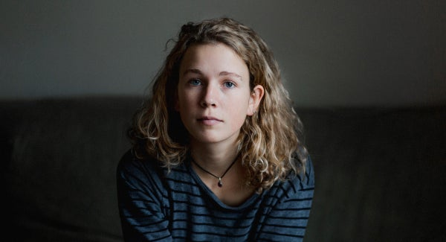Cousin Laila (on the left)

Chapter two

**Me:** Am I hallucinating right now? I have a cousin, who is my age and you never told me about her!

**My M:** Uh, oh darling you never asked, and we never told!

**Me:** Seriously mom! Do you really think would believe that lie! I asked! When I saw my other classmates talking about their cousins I came home and asked you immediately! And you said I don’t!

**My M:** Oh dear! Care to explain Laila?!

**Laila:** Yeah sure! Look you had an uncle who was uh… Kind of too much adventure loving. So, one day after another extreme adventure your grandparents couldn’t take it anymore and said he needs to choose either them or his adventures. At the time he was really crazy and left the house. After that day your grandparents refused to accept that they had a son and acted as if he never existed. However, your uncle became regretting his decision and one day returned. But nothing was as he had expected. His parents told him really hurtful things, so he decided that he would pretend his parents were dead as he couldn’t pretend, they didn’t exist. A lot of things happened since that, he met my mom, they felt that they were perfect for each other and got married and then I was born and blah, blah…. Your uncle had a stepsister who loved him a lot. His stepsister is your mom! When I grew up, I wondered if I had cousins too, just like you. And one day I gathered all the courage I had and asked my dad he told me left his family because he was stupid, but he regretted his decision ever since. And then he told me I had an aunt and a cousin my age. The moment I found out I had a cousin who was exactly my age I started searching in social Medias for people with Brown surname in the end I found your mom my father recognized her right away. So here I am! I hope that we can be best friends or at least just fiends!

**Me:** Of course, we can! I am so happy that I have a cousin! But there is only one thing I don’t understand. Mom if you loved your step sibling why didn’t you tell me about him?!

**My M:** Because your grandparents made me swear that I would never tell anyone about my brother. Not even your dad knew until today!

**Me:** Anyway, welcome to the family cousin and BFF!

**Laila:** I am so happy I finally get to meet you!

**Me:** Me too!

*So, meet my grandma and grandpa:*

*They were always there when I needed them, and I was sure that when they meet their granddaughter they will be there for her too.*

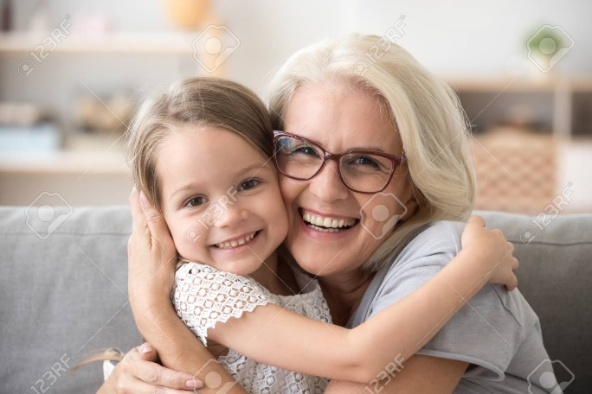Chapter three

*In front of my grandparents’ house*

**Me:** Don’t worry Laila, I am sure they will love you! It is not your fault that your father acted stupid. Oh, I am really sorry. I was meant reckless.

*I added when I realized that I was talking about her father.*

**Laila:** Yeah, I know. I wish they would just accept me for who I am.

**Me:** Of course, they will! Now just knock on the door. Believe me, they will love you!

*When I saw her hesitate, I tapped her gently on the back. My grandma opened the door. First, she saw Laila and looked surprised, but then she saw me and smiled.*

**Grandma:** Oh, Jess dear! What a nice surprise! But who is your friend I don’t recognize her?

**Me:** Can we come inside? It’s really important!

**Grandma:** Oh? Yeah, come in!

*I motioned Laila to follow me when she hesitated, I smiled encouragingly. She took a deep breath and entered the house.*

**GRANDPA:** Oh, hey Jessi! Who is our guest today?

*I looked at Laila. And when she nodded, I started talking.*

**Me:** Grandpa, I really didn’t want to talk to you about it, but I have to. I know about James (my uncle’s name)!

**GRANDPA:** We can talk about it later! Not in front of our guest! She has nothing to do with it! And I might remind Lila about her promise!

**Me:** She has everything to do with it!And don’t you dear to blame my mother, step-grandpa!

*I added angrily and his expression changed immediately.*

**Me:** I know you always wanted a real granddaughter, but as you couldn’t have one you gave all your love to me. But from today on you can give your love to your real granddaughter who is sitting right next to me! Yes, she is James’ daughter!

**GRANDPA:** What the hell-

Chapter four

**GRANDPA:** What are you talking about Jess?!

**Me:** Laila, there other part of the story is yours to-

**GRANDPA:** A girl named Laila pretends to be my son’s daughter?! Everything makes perfectly sense!

**Me:** Grandpa! Just listen to her story!

**Laila:** My other grandparents were dead, and I had nobody except my dad. My mom had died when I was born. So, when I got older, I asked my dad if we had any relatives. He said I had an aunt and a cousin. I also had grandparents, but he had acted stupidly and left the house when he was 19. After I found out about my relatives, I started searching in social media with Brown surname. After I found my aunt, Lila and her daughter Jessica. I also found you, but I didn’t risk visiting you as you told my father never to come back. I was his daughter after all! And I decided to pay my aunt a visit and they encouraged me to meet you. Also, if you don’t want to see me just like my father it’s totally OK. No need to insult me I will leave you both peacefully, but if you try to block me from contacting my aunt and my cousin then things will be-

*She couldn’t even finish her word because my grandma got up and hugged her tightly. She seemed shocked by how fast everything had happened and relieved that she had been accepted.*

**GRANDPA:** Please, sit down and listen to me. I knew you think we hate your father, but that’s not true. After the way he ran off the house I was angry and not ready to forgive him yet. But your grandma was always ready. He came back but it was really soon for me to forgive him. After I made him leave your grandma said that I didn’t understand, but I missed him too. I waved her off, but after months passed without him, I knew that she was right. I missed him, a lot, but I couldn’t talk to anyone about it. So, I pretended that he didn’t existed. However, after some time your cousin was born. Your grandma and I loved her as much as we loved your dad. And yes, Jess, you were right we gave all our love to you and only you, but I hope you are ready to share it.

**Me:** If with my cousin ALWAYS!!!

*But suddenly I remembered something*

**Me:** Wait! We have no right to be happy right now! My uncle is somewhere out there living with pain he has caused to himself and his family!

**Laila:** Yeah, Jess is right. I need to go and see my dad. He’ll be-

**GRANDPA:** Who cares what will happen to James?! What do you expect us to do?! I have all the right to be happy! I met MY REAL granddaughter!

*Suddenly my eyes filled with tears, I understood that when I thought my grandpa will always be there for me, I was WRONG. He showed me, Laila and my grandma his true face. As I looked up, I saw how my sadness filled my grandma’s heart, but my sadness reflected as shock to grandma. The shock of what her husband had said to her granddaughter. And when I turned, I saw Laila filled with shock and fear.*

**GRANDPA:** I’m sorry… I didn’t mea-

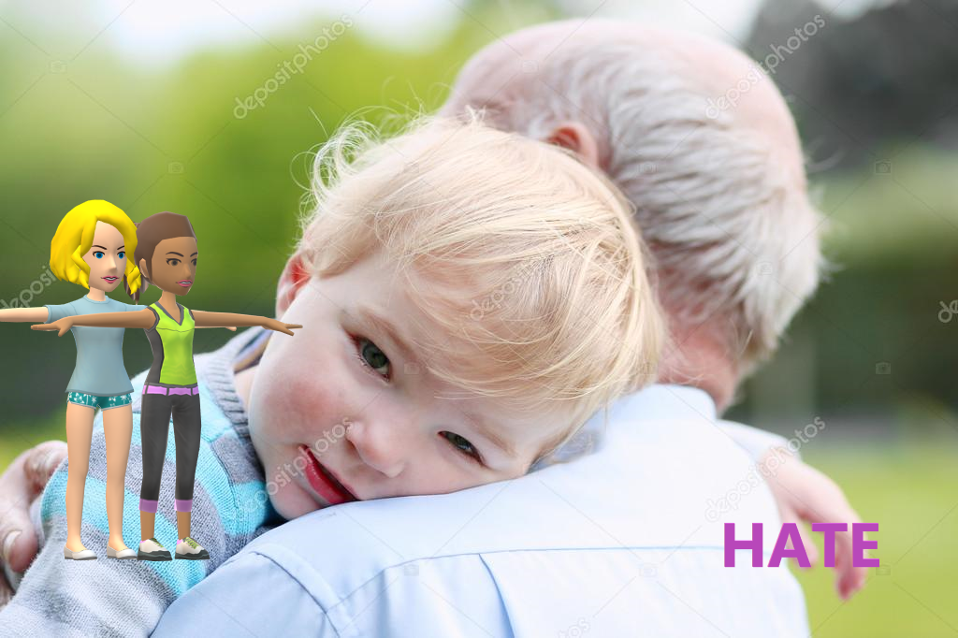

Chapter five

*As I started crying my grandma came towards me and gave me a hug. After a second or two Laila joined the hug.*

**GRANDPA:** Look I am sorry! I didn’t mean to… It just-

**Grandma:** SLIPPED?! SERIOUSLY YOU HURT ME AND MY GRANDAUGHTERS!

*I saw Laila’s whole body relax when she heard grandma say granddaughter****s******in plural.*** *She took my hand and looked at me sadly. I knew that we were both thinking the same thing. You meet your family for the first time and find out that your grandpa is crazy! How would you feel?*

**Grandma:** Come on girls, we are leaving! I will just take a few things and come. Can you wait me outside?

**GRANDPA:** LEAVING?!

**Grandma:** Try to stop me and you’ll see what happens Arthur! I had a black belt from KARATE!

*My grandpa mumbled something under his breath, but I didn’t catch it. Outside the house*

**Me:** I have never seen grandma lose her temper like this or threaten grandpa. Did I just say GRANDPA? I was going to say ARTHUR!

**Laila:** I am so sorry! This is all my fault! I shouldn’t have bothered you and YOUR family…

**Me:** MY family? Seriously?! This is YOUR family too!

*As I saw her smile sadly and nod. I knew that nothing was going to be same again after today. I was just saying those words to calm her down. In deep down my heart I knew that she was right…*

Chapter six

*So, after the incident at my grandparents’ house… did I really say GRANDPARENTS?! I meant to say grandma’s house she (G.M) moved in with us everything was the same except now Laila was living with us too. I knew she was happy living with us, but something was wrong with her. And at last I understood the reason, she was missing the most important part of her family, her father. It continued like this for several days until one day I decided to talk to her.*

**Me:** Hey Laila, have a minute for me?

**Laila:** Yeah, sure. Come in.

**Me:** Laila, are you feeling all right?

**Laila:** Yeah, sure. What wouldn’t be right?

As she shrugged, I knew that there was definitely something going on. So, I decided to approach to the topic more sensitively.

**Me:** Laila, please listen to me. You know that you can tell me anything right? I am your cousin and your BFF. Plus, if you want me to keep it a secret I will, if you want my opinion, I will tell you the best option I can think of, now is there something bothering you?

**Laila:**  Oh… UH… Yes, yes! There is something going on! I… please promise you won’t tell anybody!

**Me:** Of course!

**Laila:** I… I… I miss my dad! I miss him a lot! I know he misses me too! I want to go back home, but I can’t leave you either! You are my family too…

**Me:** Oh Laila! I have got a solution, but before I say it…

*I went up to her and hugged her*

**Me:** So, for the plan to work first, we need to go and visit your dad and see what he thinks about it.

**Laila:** All right… But can you tell me the plan?

**Me:** Nope, not yet…

Chapter seven

*Today I am meeting my uncle. We didn’t tell my parents because we didn’t want them to come with us that’s why we told them we were going shopping. I was very happy to meet my uncle and Laila was happy to see her father.*

*In front of my uncle’s house*

**Laila:** Are you ready?

**Me:** Yeah, I am! Please, you knock the door!

*Laila knocks on the door and a young man opened it. He looked like Arthur’s younger version. When he saw Laila, his face lit up.*

**Uncle James:** Laila, you are back! And who may be our guest?

*For a moment he looked at my eyes and looked startled, but then he seemed to think it was just a coincidence.*

**UNCLE:** Yeah Laila, may you introduce me your friend?

**Laila:** Let’s go inside dad, I will tell you everything there with the help of Jess.

*We entered the house and the first thing I saw was some family pictures, except I was not there.*

**UNCLE:** So, you are called Jess. Laila, where did you meet this young lady who reminds me of somebody.

**Laila:** Uh… Jess you go…

**Me:** Me? I can’t! UH! Fine!

*I took a deep breath… And…*

**Me:** HI UNCLE!

**UNCLE:** Oh… Is your friend alright, Laila?

**Laila:** Jess, I thought we were going to tell everything slowly!

**Me:** What can I do?! How did you feel when you met my mom?!

**Laila:** I felt… nervous, exited, sick?!

**UNCLE:** Laila, I think you have got a lot of things explain!

**Laila:** Dad… She is your niece…

*Suddenly my uncle burst into laughter when no one laughed he understood that we were serious.*

**UNCLE:** It can’t be my family hates me! They would never come and visit me!

**Laila:** Well, that’s your personal opinion!

**UNCLE:** But… Wait! Laila is this a prank?! I used to do this kind of things when I was your age. Are you trying to cheer me up by lying? It is not cheering me up!

**Laila:** Dad! Do you really thing I would lie to you?! Anyway, she can even take you to her parents or…

**UNCLE:** If she is really my niece, she needs to know the family tree. I didn’t tell you about my aunts, uncles and grandparents, so you couldn’t have taught her about it. Let’s begin…

After half an hour of family tree questions

**UNCLE:** And now the last question who is Midge?

**Me:** My step great-grand aunt-

**UNCLE:** This question was really hard to guess, but you go it right… Interesting… Seems like you are really lucky in guesses-

**Me:** I- AM- NOT! Maybe I am really your niece my mother’s step-bother!

**UNCLE:** Seriou- Wait! Did you just say *MY MOTHER’S STEP-BROTHER?!*

**Me:** Yeah, so what?

**UNCLE:** I never told Laila that Lila was my stepsister, how do you know?!

**Me:** For the reason I know your mother was named Pomona and your father was named Arthur. Trust me, I know who you are *Uncle* James.

*As I said uncle, I saw that he really seemed to accept me. But it was time to cut to the plan.*

**Me:** Uncle James, for whole these years your family never hated you. It was just your dad, but he was just angry. He still loved you like he had loved no one else in this world. When one day I came home, and my mom said that I had a cousin I accepted her the moment I saw her because she had the eyes of my grandma. They were the exact shade of green as mine too. So, look up at my eyes, can’t you see the mark of Browns?

**UNCLE:** I can, I saw it the moment I looked at you. I just told myself that it couldn’t be. Even if it was you, I thought you would never accept me because of what I did!

**Me:** Don’t worry everyone can make mistakes. You are lucky I am here to help you to make it right! So, when we came here today, I told my parents that we were going shopping and will be back before 6 o’clock. So, we only got half an hour and the way is long. That’s why we need to say goodbye for now.

**UNCLE:** For now?

**Me:** Do you really think that you will live in this mess forever? Let’s go Laila or my parents will be worried.

Chapter eight

*The next morning, I took my uncle’s number from Laila and texted him the plan. Now, let me tell you the plan. Laila cannot stay with us forever and her house is really far that’s why my uncle was going to buy an apartment in neighborhood. My parents always go and visit new neighbors that’s why my parents will go and greet the new “neighbor”. So, when they see my uncle, they will be shocked, but happy. In my uncle’s thoughts if they won’t be happy to see him, he will sell the apartment and move back to his old house. I know what you think, what about Laila. Well, if the plan works, she will live with her father in the neighborhood, if it doesn’t… Uh, we will think about it later. Also, there is no chance that it will fail I can guarantee.*

*A week later*

*Today my uncle is moving in. my parents already saw the boxes and understood that someone is moving in. and I heard them talking about when to visit the new neighbor. In the end they decided to meet the neighbor he next day. Laila and I decided to go too, so if something happen, we can be there for my uncle.*

*The next day, in front of the “new neighbors” house*

*My mom knocks on the door. My uncle opens it. They look at each other for a moment and then hugged. My dad looked confused and a little bit angry.*

**DAD:** Lila, what’s going on?!

**MOM:** Alex, meet James, my brother!

**DAD:** James? Laila’s father and Jess’ uncle?

**MOM:** And my brother! Yes, this is James!

*My dad held his hand towards my uncle, and he shook it. He looked confused at how things became like this so fast.*

*And this is how I spent my Christmas holidays. You may think this is the end of the part, but it is not. New Year is close bye and we have been waiting for it for days.*

*Part 3*

***I am kidnapped! Help!***

*Chapter one*

*On New Year’s Day Laila and I went on a morning walk. After that on our way back home, suddenly someone hit Laila and she fainted. I wanted to scream for help, but I can’t remember what happened later, but I woke up next to Laila in a basement. First, I thought that someone kidnapped us, but then I recognized the place as my grandma’s basement. Then a thought strokes me. Arthur had kidnapped us. First, I panicked, but then I understood that there was no need to worry. I knew all the hide outs in the house. Some of them no one knew except me. So, I woke Laila up. She panicked the moment she looked around. I calmed her down and told her everything. She calmed too.*

**Laila:** We need to think of a plan. Where is the door?

**Me:** There is door above your head and on the left corner. The door on the left is the way directly outside. If Arthur locked that door there is only one way out, the door above your head and if we use that door we will need to go inside the house. I am sure Arthur locked the door on the left but forgot about the door above because no one uses that door. Let’s try the left door first.

**Laila:** It’s locked! Just as you predicted!

**Me:** Alright. Now the door above

**Laila:** It’s too high! I can’t reach it! We are stuck in here!

**Me:** Seriously?! I grew up in here! I know every inch of this place and just a door would stop me?!

**Laila:** What?! You are going to fly?

**Me:** Very funny, Laila! There is a chair in here!

**Laila:** Didn’t you just say that no one enters here? Why would there be a chair in here?!

**Me:** Silly! It’s a really old chair. They wanted to sell it when I was 6, but eventually they forgot about it. It’s not really safe, but worth a try. You or me?

**Laila:** Doesn’t matter. Maybe you? You know the house better. I mean if you don’t want to, I will go.

**Me:** I will go!

*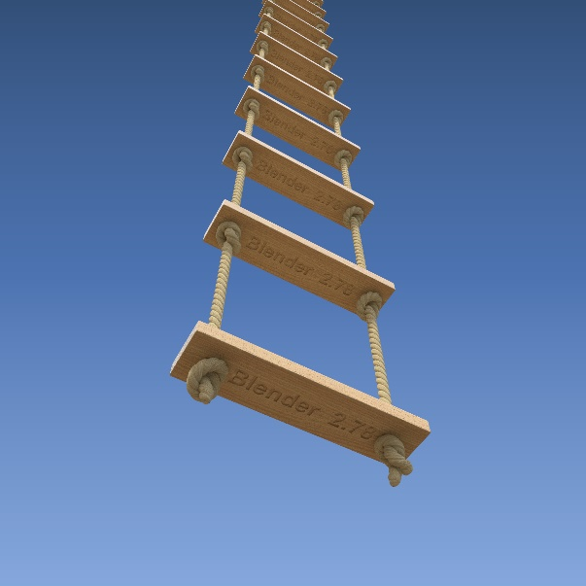I carefully climbed the chair and opened the door after I looked carefully around. Arthur was nowhere to be seen. I motioned Laila to wait and not to hurry. After, I put down a rope ladder (on the right). She climbed carefully up and when she was on her last step, I heard Arthur coming she hurried and reached me, but it was late. Again, I felt pain and my life flashed before my eyes…*

*Sometime later*

*We woke up in another room this time. I knew that the door was locked, but I am a perfect lockpicker. I know what you are thinking, why didn’t I lockpick the other door. The reason is when I was younger, I always wanted to play in the basement, but Arthur didn’t think it was appropriate. So, he set up some traps in front of the door.*

**Me:** Laila, do you have a hairpin?

**Laila:** Yes, for what?

**Me:** Come on, just give it to me!

Chapter two

*I lockpicked the door and beckoned her to follow me there was a secret bookshelf door which belonged to my grandpa. I knew he wouldn’t search for us in there because he had no idea, I knew about it. I found it when I was 9 and asked grandma about. She got really scared as grandpa had forbid entrance in there. So, she told me to forget about it and not to mention it to anyone. I did as she asked, but I never really forgot about it completely. As I came next to the bookshelf, I remembered that the real reason I had found the bookshelf was that I had guessed the password. I looked through my memory and found the password, it was James. As we entered the room, I quickly changed the password to Auradon, my boarding school so that Arthur couldn’t get in. I looked up at Laila and mouthed quiet.*

**Me:** We are safe in here! He can’t get in without a password.

**Laila:** Then, we are not! He surely knows his own password!

**Me:** He may know his own, but I changed the password when we entered… Wait! We are not safe at all!

**Laila:** Didn’t you just say we are safe?!

**Me:** I thought so! But know I remember with just one touch at his phone Arthur can close all the security systems. We need to get out of here now!

**Laila:** How? If we go back to corridor, he will surely see us!

**Me:** Another golden fact- thee is a secret passageway in here. I found it when I was exploring this room. Look!

*As I pulled one of the books down from the shelf wall divided. And a passageway was visible.*

**Laila:** But where does it lead?

**Me:** I don’t know that, but if it is another secret room, I will recognize it for sure! Come on hurry! I can hear footsteps!

**Laila:** But-

*We hurried across the tunnel and reached a really circular room.*

**Laila:** Do you recognize the place?!

**Me:** I do, but most of the times the door to the corridor from here is locked. Let me check it… It is open! Come on! Follow me, let’s get out of here! Arthur is using the passageway!

*As we hurried through the dark corridor, I understood that we could only get out of the house unnoticed by a secret passageway. That’s why when I stopped in front of the front door and dragged Laila back, she looked surprised.*

**Laila:** What are you doing?! Let’s get out of her! Now! He is coming closer!

**Me:** No time to explain! Follow me!

*As she followed me, I explained everything to her in a quiet tone*

**Me:** We may be able to get out of the house, but he will know it immediately because of the security system. He cannot run as fast as us however he has a car. That’s why we need to use a secret passage. Even he doesn’t know about it as it is really old. This house belonged to my ancestors my grandma showed me this passageway and told me not to tell grandpa, he is not actually from our family. I didn’t really care about that word at that time, but I still kept it a secret because I liked having a secret that he didn’t know. It was in my mom’s old bedroom which was mine after my mom grew up. Sometimes when I stayed overnight in here, I slept in there.

*I looked around and opened the door carefully. I knew that he would know where we were the moment, we enter the room. I took a deep breath and opened the door, security system activated. I quickly ran inside locked the door, opened the wardrobe and pulled one of the drawers. At that moment wardrobe transformed into a door. I quickly opened it motioned Laila to follow me. As we entered the door transformed into a wardrobe again.*

**Laila:** Wow! This place is amazing!

**Me:** I know! Imagine, I grew up in here!

*The secret passageway was like a child room, it was filled with toys, books, posters. There was a desk and an armchair.*

**Me:** We are nearly there, just a few more turns. By the way this passage can lead into any room in the house.

**Laila:** Really?! I wish I could have childhood as yours…

*As she sighed sadly, I understood how much different our lives were even though we were from the same family and the same age. Also, I realized how much our lives had changed when we met each other. I smiled sadly at her and she smiled back. At last we reached the end of the passage.*

**Me:** Laila we are at the end of the passage, ready?

**Laila:** As always!

*Together we stepped out of the passage and started running as fast as we could. We reached the bus stop, took the bus, when it was our stop we got out of the bus as fast as we could and started running again towards my house which was closer to the bus station. When we reached the doorsteps, we started knocking as fast as we could. My grandma opened the door, she looked really worried. When we through ourselves inside the house without a word, I knew she was wondering what happened because of the look on her face. As we entered living room, I saw my parents exchanging worried looks…*

Chapter three

**DAD:** Uh… Honey? Are you alright? You seem kind of pale… And today your morning walk took a little TOO long… We were really worried. I know you told us you were not a baby and you could take care of yourself but…

**Me:** Mom, dad I am so sorry you can’t imagine that your worry is just what I need right now!

*I actually meant what I said, but I am a sarcasm person. That’s why my parents thought I was angry.*

**Mom:** Oh honey! Don’t get mad at your dad, he was just trying to say that-

**Me:** Oh mom! I wasn’t being sarcastic, I am serious!

**Mom:** You are? Are you alright, your face is scarred?

**Laila:** Oh, Lila scars are nothing compared to what happened on our «little morning walk». Why don’t you start telling them what happened in the park?

**Me:** Seriously Laila? I am tired and traumatised! At least give me a day!

**Laila:** I think a minute would be enough. I would have told you Lila, but I am sure my father is really worried.

**Me:** Come on Laila! We can give your father a call and he will be here in five minutes. Please?

**Laila:** Fine! But I am not telling the whole story, you got to help me afterwards, deal?

**Me:** Deal!

**Laila:** Alright, here goes nothing! Jess and I were in our usual spot talking, laughing, joking you get the idea and suddenly I felt everything go black and the next thing I know is that I wake up in a basement. Your turn!

*As Laila addressed me with a nod I stated shaking with terror. How am I going to tell something like this about somebody who I loved with all my heart until yesterday! But truth couldn’t be hidden forever, that’s why I took a deep breath and when Laila gave me a meaningful look I started talking.*

**Me:** Just like Laila I woke up in the basement, but unlike her I recognized the place. It was Granny’s house, Mom!

**Mom:** What?! How did you go there you didn’t have your bus tickets?

**Me:** Yep, that’s what I wondered when I woke up in the familiar basement, but then…

*and I told them everything without leaving any detail. At first, they didn’t believe me and after-*

**Me:** Seriously mom?! Why would I lie to you?!And besides I don’t have my phone! You know better than anybody that I never keep my phone away *(not that I am addicted, but my phone contains all my private info. I even have an online diary*😅*)*!

*And that exact moment my parents understood that I was not lying, they knew that I would never have my phone away from me because all of my passwords, contacts and many other important stuff is in there. After everything that had happened my granny thought I was traumatized and made me a cup of hot chocolate* (my favorite type of coffee) …

*A month passed since all of this and life still continues. I go to Auradon with my bestie Laila and my other bestie Belle. After school I am planning to study law in Harvard. Sadly, in that part of my life both of my besties will leave as Laila wants to be a pilot and Belle wants to be a vet. Everything is same at home, except grandma lives with uncle James.*

*This is how I spent my kidnapping adventure with my bestie…*